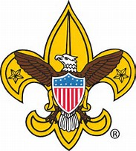
BSA Troop 325
First United Methodist Church
404 Azalea, Lake Jackson, Tx 77566
Scout Master: Joe R. Moreno 979-264-1752 Committee Chair: Mike Carter 979-373-7745
BSA Troop 325 gratefully acknowledges the following charitable contribution to
the Troop and thanks the donor for their charitable donation.
Purpose of Donation: ________________________________________________
Donor’s Name: _____________________________________________________
Donor’s Address:____________________________________________________
Date of Donation:___________________________________________________
Cash Donated:______________________________________________________

Property Donated:___________________________________________________
Description:________________________________________________________
Value:_____________________________________________________________
Thank you for your contribution to Troop 325
Leader Signature:__Joe R. Moreno Title:_Scoutmaster___

